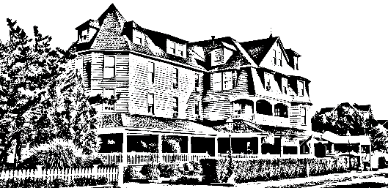

*The Grenville*

*Hotel & Restaurant*

Easter Day

Shrimp Cocktail

Omelet Station with traditional fixing

Stuffed French Toast/ Waffles

Bacon/ Sausage

Roasted Potatoes/ Sautéed Vegetables

Cuts of Meat: Ham, & Pork

Chicken Francaise

Swedish Meatballs

Penne Vodka

Eggplant Rollatini

Beef Tips

Seafood Ensemble: Sea bass, Mussels, Clams, Shrimp

Carving Station: Lamb OR NY Strip

Caesar Salad/ Mixed Green Salad

Assorted Bread Basket

Assorted Desserts



$39.99 per adult & $29.99 per child

*\*This does not include tax, gratuity or beverages*

*Please let your server know if there are any food allergies or if you do not prefer one of the entrees included in the platter.*